**Q1 Programming Fundamental**

**IF STATEMENT**

When decisions are made in a computer program, they are simply the result of a calculation, where the result is either true or false. Computer programs have no intuition or "feeling"; they simply make thousands of yes or no decisions with blinding speed. A computer programmer must adjust these decisions within the algorithm of a computer program to achieve the desired result. In computer programming languages, selection statements (also known as decision statements) are used to allow the programmer to do this. Like most computer languages, Java includes if statements as a type of selection statement. Another selection statement is the change statement (similar to the Visual Basic Select case).

Practically all computer languages have some sort of if statement. An if statement is a one-way selection statement. Here is an example of an if statement:

**if (number == 3)  
{  
   System.out.println("The value of number is 3");  
   System.out.println("Goodbye");  
}**

You can use the logical operators && (AND), || (OR) , and ! (NOT) within control expressions in an if statement.

**IF Else Statement**

The following flowchart demonstrates that if the condition (the boolean expression) is true, one block of statements is executed, but if the condition is false, a different block of statements inside the else clause is executed.

**Flow Chart**

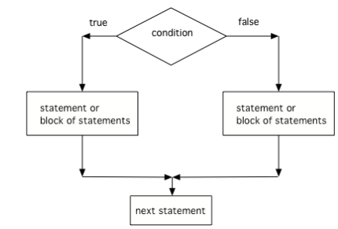

**Code**

**A = 50;**

**If (a==20)**

**{**

**Statement 1;**

**}**

**Else**

**{**

**Other statement**

**}**

**Nested Ifs and Else**

If statements can be nested inside other if statements. Sometimes with nested ifs we find a else that could potentially belong to either if statement. The rule is that the else clause will always be a part of the closest if statement in the same block of code, regardless of indentation.

**Code**

**If (condition){**

**If (codition2){**

**Statement1  
}**

**Else {**

**Statement 2**

**}**

**Cascading If Else**

A cascading if-else is a composite of if-else statements where the false path of the outer statement is a nested if-else statement. The nesting can continue to several levels.

**Code**

**if ( score >= 90 )**

**grade = 'A';**

**else**

**if ( score >= 80 )**

**grade = 'B';**

**else**

**if ( score >= 70 )**

**grade = 'C';**

**else**

**if ( score >= 60 )grade = 'D';**

**else**

**grade = 'F';**

**NATURAL NUMBERS USING FOR LOOP**

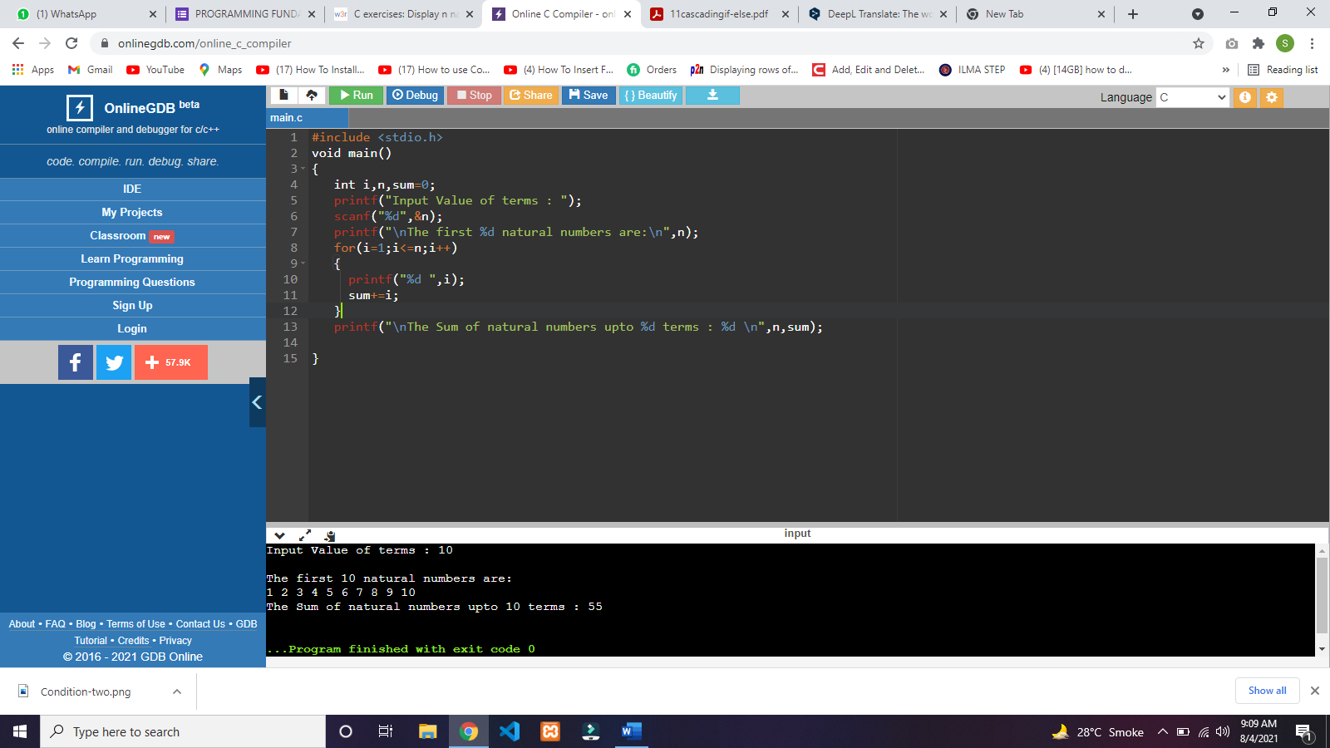

**Code**

**#include <stdio.h>**

**void main()**

**{**

**int i,n,sum=0;**

**printf("Input Value of terms : ");**

**scanf("%d",&n);**

**printf("\nThe first %d natural numbers are:\n",n);**

**for(i=1;i<=n;i++)**

**{**

**printf("%d ",i);**

**sum+=i;**

**}**

**printf("\nThe Sum of natural numbers upto %d terms : %d \n",n,sum);**

**}**